**Matica Biotechnology and Cirsium Biosciences Announce AAV Manufacturing Collaboration**

Collaboration integrates breakthrough plant-based technology with downstream and analytical expertise to support innovation in gene therapy manufacturing

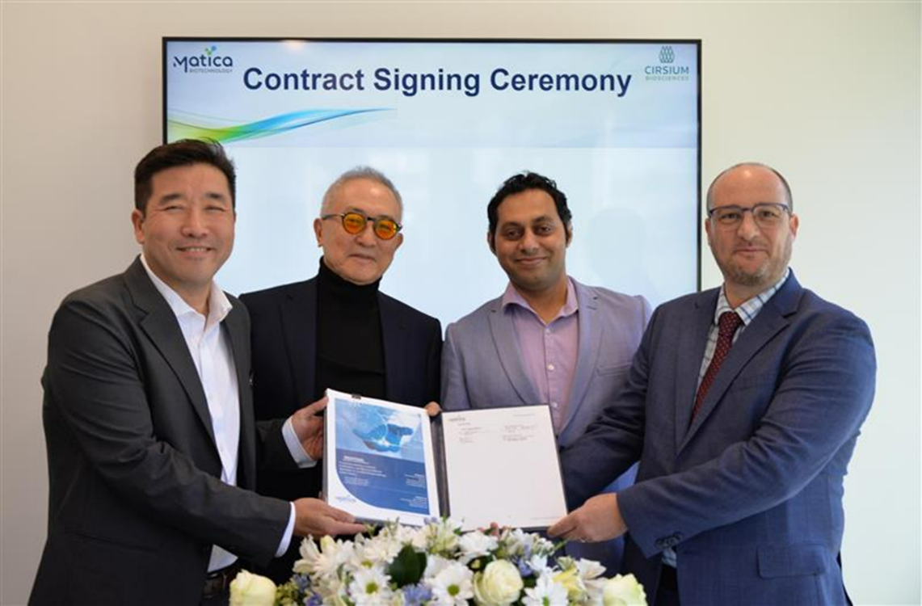

(From Left to Right : Paul Kim, CEO of Matica Bio; Dr. GY Cha, Founder of Matica Bio and Chairman of CHA Hospital Group;  
Dr. Pranav Mathur, Director of R&D at Cirsium; Dr. Daniel Gibbs, CEO of Cirsium)

**COLLEGE STATION, Texas and SAN DIEGO, California - (September 8th, 2025) - **Matica Biotechnology, Inc. (Matica Bio), a leading contract development and manufacturing organization (CDMO) specializing in viral vector production, and Cirsium Biosciences (“Cirsium”), a biotechnology company developing a breakthrough plant-based AAV technology, today announced a non-exclusive strategic partnership.

This collaboration embodies Cirsium’s hybrid hub-and-spoke manufacturing model, which combines internal plant-based AAV production capabilities with downstream collaborators to maximize flexibility, scalability, and distribution. Through this agreement, Matica Bio becomes an early adopter and partner, providing analytical and downstream support that complements Cirsium’s technology.

The cost and efficiency of AAV manufacturing remain significant constraints on gene therapy development and accessibility. Solutions that shorten production cycles and scale efficiently will be pivotal to sustaining industry growth. Together, Matica Bio and Cirsium aim to support more efficient manufacturing processes to enable rapid and more broad access to patients.

“Partnering with Cirsium means working alongside a company committed to advancing innovation in gene therapy,” said Paul Kim, CEO of Matica Bio. “We are proud to be an early partner in this decentralized model. Their innovative technology aligns seamlessly with our extensive capabilities in viral vector development and the manufacturing of clinical products. Together, we’re working to shape the future of next-generation treatments and expand availability to more patients.”

“Our hub-and-spoke model allows us to partner with leading organizations like Matica Bio to expand AAV manufacturing flexibility and scalability,” said Dr. Daniel Gibbs, CEO of Cirsium. “This collaboration reflects our mission to pursue more efficient approaches to gene therapy manufacturing.

**About Matica Biotechnology, Inc.**  
Matica Biotechnology is a viral vector Contract Development and Manufacturing Organization (CDMO) that leverages advanced technologies at its purpose-built cGMP facility. With industry-leading expertise in process development, assay development, and cGMP manufacturing, Matica Bio serves as a trusted partner, seamlessly supporting its clients with streamlined operations throughout every stage of projects. Collaborating across five Matica sites worldwide, Matica Bio delivers excellence in the CDMO domain through innovations such as MatiMax™ proprietary cell lines, in-line process monitoring, and single-use technologies. Visit [www.maticabio.com](http://www.maticabio.com) for more information.

**About Cirsium Biosciences**  
Cirsium Biosciences is an innovative biotech company in San Diego, California, that uses plant-based technology to provide scalable, rapid, and high-quality production of viral vectors, spanning from research to commercial scale. Named after the resilient thistle plants Cirsium vulgare and Cirsium occidentale, which thrive in harsh environments, sustain life, and adapt to new landscapes, Cirsium enables AAV therapy developers and partners to overcome manufacturing and commercial hurdles, scale advancing programs, and pave the way for broader availability of future therapies. Discover more at [www.cirsiumbio.com](https://www.cirsiumbio.com)

**Inquiries**

**Matica Bio:**

**Matica to provide info**

**Cirsium Biosciences:**

**Partnerships & Investors**  
Adam Roose  
Vice President of Business Development  
[BD@cirsiumbio.com](mailto:BD@cirsiumbio.com)

**Media Inquiries**  
Allison Satterfield  
Director of Marketing   
[media@cirsiumbio.com](mailto:media@cirsiumbio.com)